Our Careers Strategy: Introduction
Our commitment
There has never been a time when careers guidance has been as important for young people as it is today. At Overton school, we have a critical role to play in preparing our learners for the next stage of their education or training and beyond. Our learners will be embarking upon a career pathway, which is more challenging and complex than that faced by previous generations. Global opportunities and increasing technological advances will result in young people having several careers during their working life and potentially working in a career that does not currently exist.
With the greater choices of education, training and employment, our aim is to prepare learners for these ever-changing opportunities, responsibilities and experiences and to equip them with the skills to manage the choices, changes and transitions ahead of them.

Whole School Approach
We have a whole school approach to careers education with every member of staff helping to deliver quality and impartial Careers Education, Information, Advice and Guidance, allowing learners to access the necessary information to help them make informed decisions about their futures. Our careers programme throughout the year supports our careers education curriculum and in line with the most recent careers guidance strategy (June 2025), our careers plan supports the achievement of the eight Gatsby benchmarks. Careers Education at Overton School is not just a stand-alone strand; it is integrated into every area of the school and woven into the school curriculum. Our aim is that learners understand how what they are being taught will link to their future pathways.
We work closely with The Careers and Enterprise Company. Our independent careers advisor is Kay Evans who supports us with one-to-one interviews for all KS4 pupils as well as curriculum support and general advice.

Aims and Objectives
The careers education, information and guidance programme is designed to meet the needs of each and every learner at Overton School. It is differentiated to ensure progression through activities that are appropriate to our learners’ stages of career learning, planning and development.
The main aims of the careers provision at Overton School are to:
Develop and maintain a culture of high aspirations through a fully embedded careers education, advice, information and guidance programme.
To raise and track learners’ engagement within the careers programme during their journey through Overton School and evaluate to ensure that learners are supported in raising their aspirations whilst being mindful of the ever-changing and competitive world around them.
Build a continuously increasing and relevant network of partners and providers who can engage learners in developing their career pathways. These partners will work in partnership with subject areas/key stages to develop collaborations enabling opportunities for learners to see clear links between their subject learning and the world of work or future aspirations.
To learn the aspirations in life of each individual learner and address these aspirations by carefully introducing realistic elements and experiences into their day to day education which will go some way towards meeting their aspirations.

Legal framework
This policy has due regard to legislation and statutory guidance, including, but not limited to, the following:
DfE ‘Careers guidance and access for education and training providers’ 2018
Education Act 1997
Education and Skills Act 2008
Apprenticeships, Skills, Children and Learning Act 2009
Equality Act 2010
Children and Families Act 2014
Technical and Further Education Act 2017

Addressing the needs of pupils
Overton School’s careers programme will aim to raise the aspirations of all learners whilst being tailored to individual needs. The programme will inform learners of the range of opportunities available to them, encouraging them to aim higher and make choices relevant to what they feel they can achieve. We are inclusive and encourage our SEND students to consider the widest possible range of careers and aspirations. Comprehensive and accurate records will be kept to support the career development of learners. Destination data will be retained by the school for at least three years.
Pupils with SEND
Overton school will ensure that careers guidance is differentiated and based on high aspirations and a personalised approach. The careers leader will work closely with the SEND coordinator and other staff to support learners with understanding different career and education pathways and how to develop the necessary skills, knowledge, experience and qualifications to succeed and fulfil their potential. The school will work with families of learners to help them understand what career and education options are available. Surveys will be conducted to find out individual learners’ aspirations. The results of the surveys will create careers and education guidance and experience that will be tailored to learners needs based on their own aspirations and abilities. Careers guidance will take account of the full range of relevant education, training and employment opportunities. It will inform learners about the ways employees with SEND are supported in the workplace, and how jobs can be adapted to fit a person’s abilities. The school will build partnerships with businesses and other employers, employment services, and disability and other voluntary organisations. Learners will be prepared for encounters with employers and provided with any special support that will allow them to benefit fully from the experience. Careers guidance will focus on the learners’ career aspirations and the post-16 options which are most likely to give the learner a pathway into employment or HE.
Learners with SEND will have the opportunity to hear from adults with disabilities who have succeeded in their careers as part of the school’s successful careers strategy. When arranging work experience for learners, the school will work with the employer to determine any additional support that will be needed during the work placement.
Staff Training and Updates
Overton School’s careers programme will ensure that all staff are kept up to date with all relevant information. This will include the following:
A copy of the Careers Strategy and Policy
A copy of the CPD calendar showing all relevant training sessions
Emails to share updates about local and national initiatives such as National Careers Week
Termly update to share relevant local/national Labour Market Information (LMI) so that staff can have appropriate conversations with learners
Development of a specific Careers Calendar showing local and national events and initiatives that staff can become involved with

External Engagement Planning
On an ongoing basis, Overton School is working towards Engaging with a strong network of local employers able to offer a range of experiences for our learners including site visits, apprenticeship workshops, visits into school to present their company, work experience opportunities and employer engagement videos
Development of our alternative placement opportunities network to include work experience for all pupils in KS4
Develop opportunities for learners to gain greater experience of the workplace including more hands on and practical opportunities (e.g. Lower Bush Farm, Ludlow Food Bank, Herefordshire NHS trust)
Develop opportunities for our younger pupils to gain an understanding of different jobs and employment opportunities in their local area
Engage with local careers fares, open days and visit other local events relevant to our learners
Engage parents/carers in Careers Education
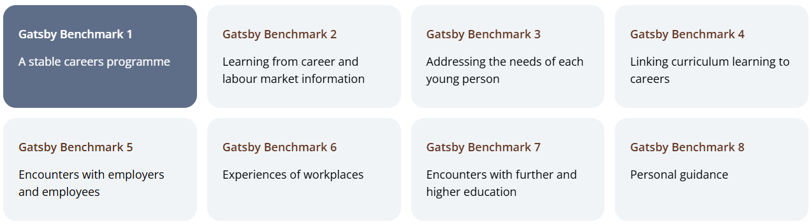

Policy Reviewed By: | Martin Leese | Signature  M.Leese | Date  20/06/25
Independent Careers Advisor | Kay Evans
Next Review Date: | September 2025 |  | June 2025
Interim Review Comments:

Policy Reviewed By:
Next Review Date:
Interim Review Comments:

Policy Reviewed By:
Next Review Date:
Interim Review Comments:

Policy Reviewed By:
Next Review Date:
Interim Review Comments:

