Meet Evie – Overton School's New Therapy Dog
Dear Parents and Carers,
I'm delighted to introduce a wonderful new addition to our school community – Evie, our school therapy dog!
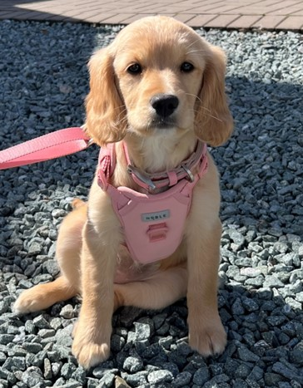

Who is Evie?
Evie is a Golden Doodle (Golden Retriever / Cockapoo) who is being specially trained to work in school settings. She has a calm, gentle temperament and loves spending time with children. Evie will be working alongside all staff and will be a regular presence around school.
How will Evie support our pupils?
Research shows that therapy dogs can have a hugely positive impact on children's wellbeing and learning. Evie will help our pupils by:
- Providing emotional support and comfort during times of stress or anxiety
- Helping children develop confidence and social skills
- Creating a calming presence in the classroom and around school
- Supporting reading development – many children find reading aloud to a dog less intimidating than reading to an adult
- Encouraging responsibility and empathy
Safety and hygiene
We've put careful measures in place to ensure Evie's presence is safe and hygienic for all pupils:
- Evie is fully vaccinated, regularly groomed, and health-checked by a vet
- She is undergoing temperament assessments and training specifically for working with children
- A designated member of staff (Nicola as Headteacher initially) will supervise all interactions with Evie
- Hand-washing facilities will be available, and children will be reminded to wash their hands after contact with Evie
- Evie will have her own designated rest area away from pupils when she's not working
What if my child has allergies or is nervous around dogs?
We understand that some children may have allergies or feel anxious around dogs. Please let us know if this applies to your child, and we'll make appropriate arrangements to ensure they feel comfortable and safe. No child will be required to interact with Evie if they prefer not to.
Meeting Evie
We'll be introducing Evie to the children gradually over the coming weeks.
If you have any questions or concerns about Evie joining our school community, please don't hesitate to get in touch with the SLT team.
We're confident that Evie will bring joy, comfort, and valuable learning experiences to our pupils, and we look forward to seeing the positive impact she'll have.
Warm regards,
Richeard Lort
Assistant Head
Overton School

